Probability & Statistics B2+TB2 Project Report Team 11
Prepared By: Advay Vivek 24BCT0136 advay.vivek2024@vitstudent.ac.in

Screenshots:
Uploading the DataSets in the Dashboard basic analysis:
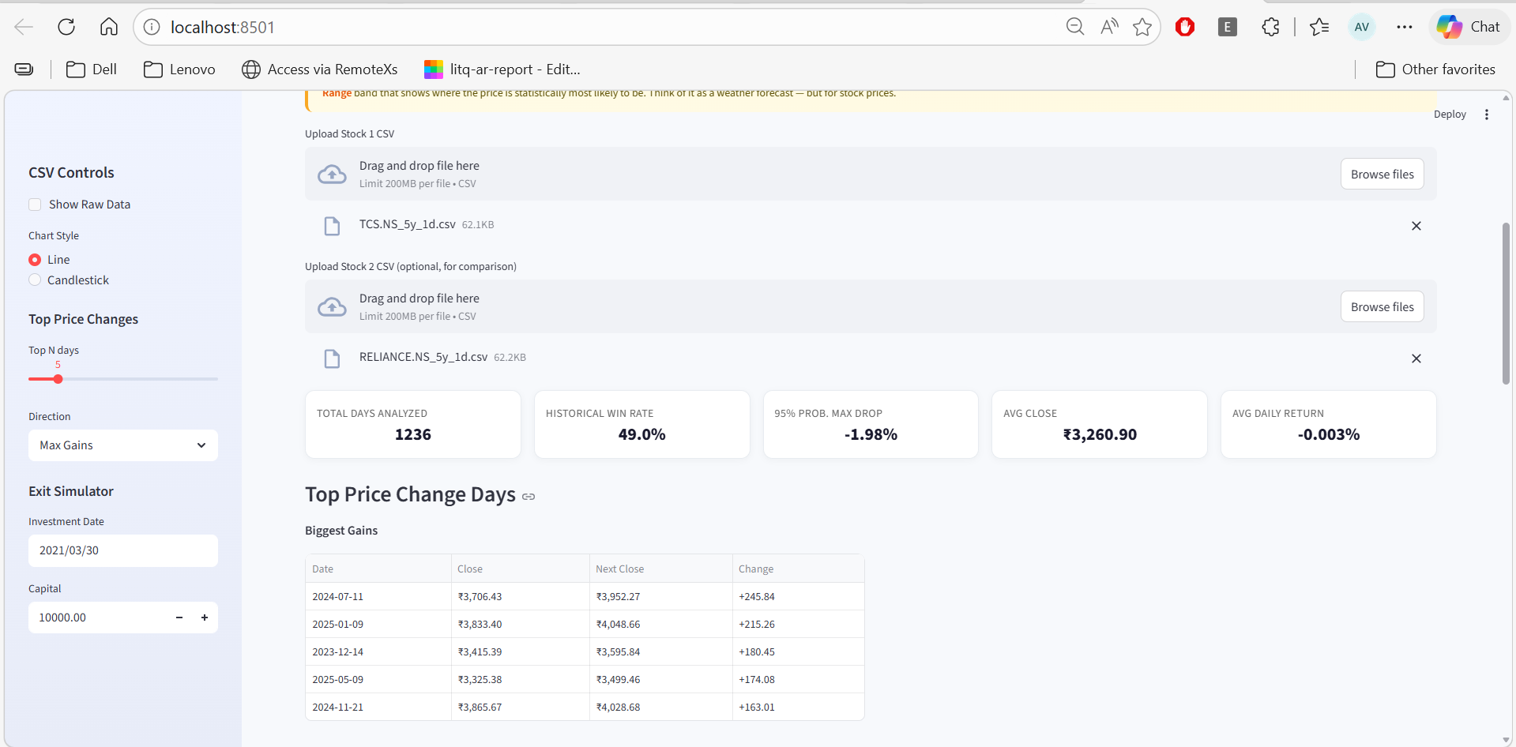

Using Regression(for the TCS 5y dataset):
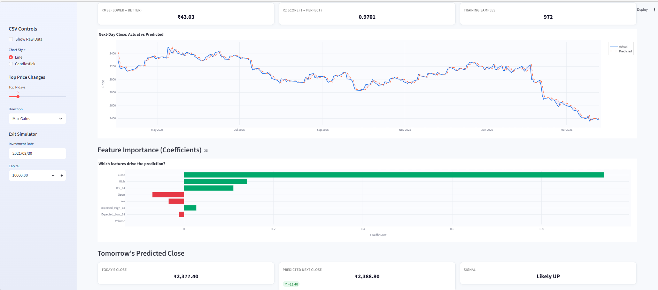

Monte Carlo Simulation(for the TCS 5y dataset):
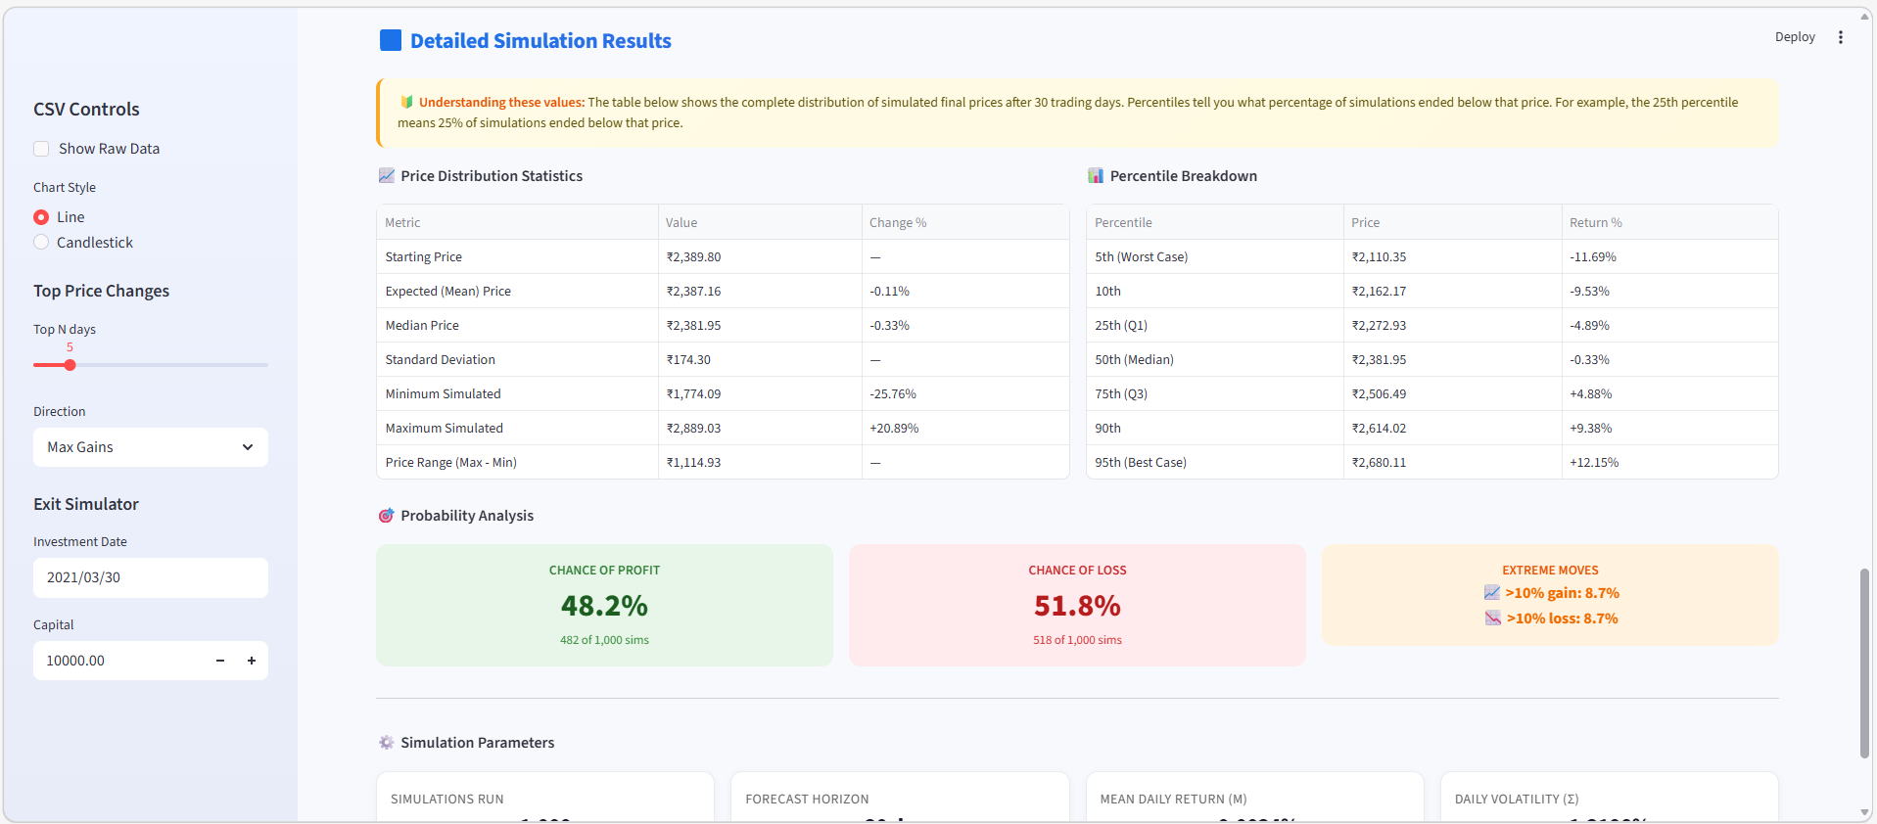

Anomaly Detection using Isolation Forest(ML Method) (for the TCS 5y dataset):
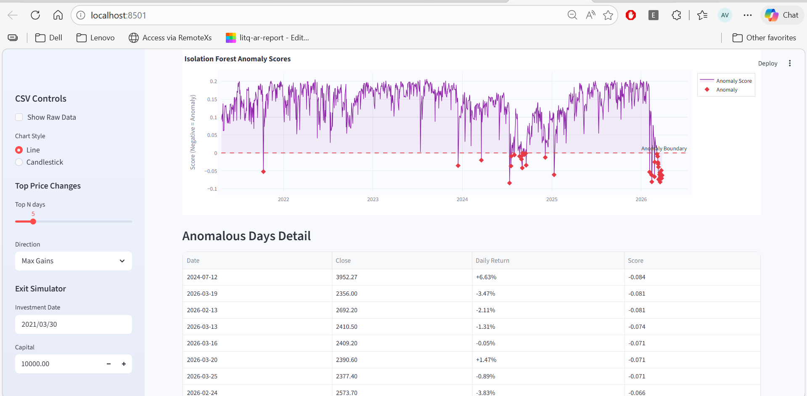

Statistics Tab(for the TCS 5y dataset):
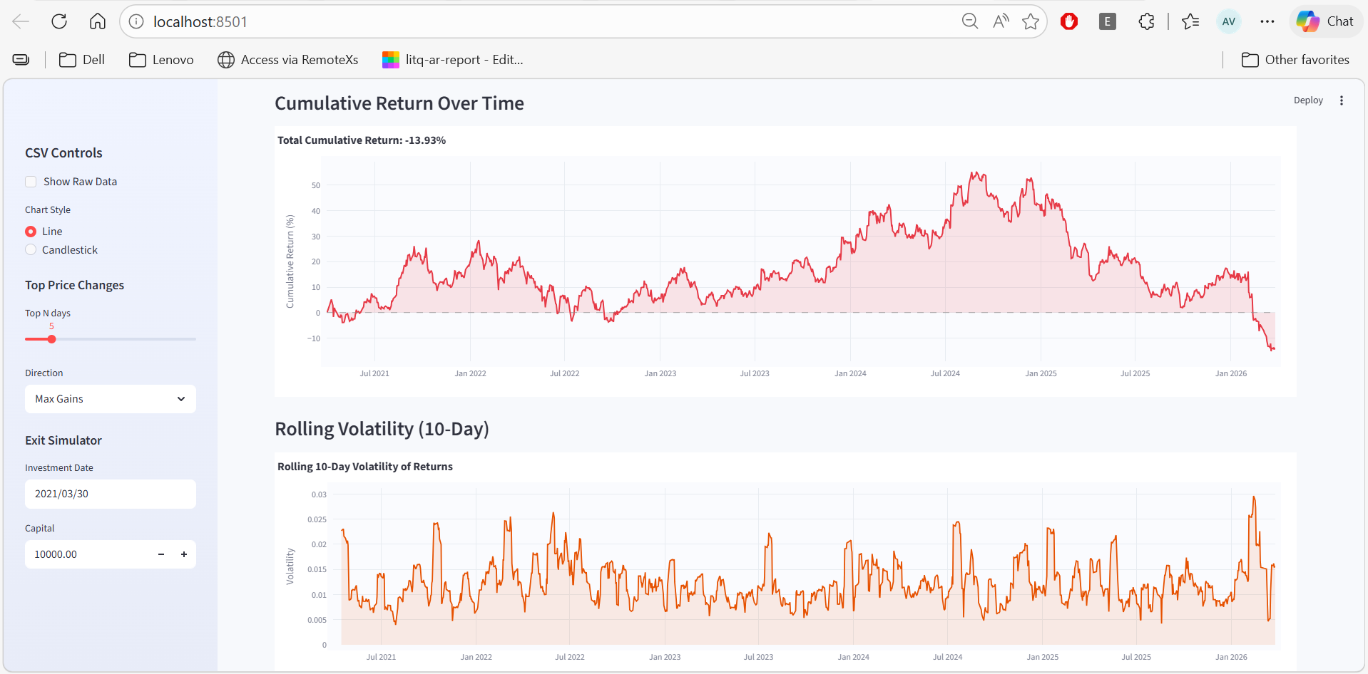

Summary Tab:
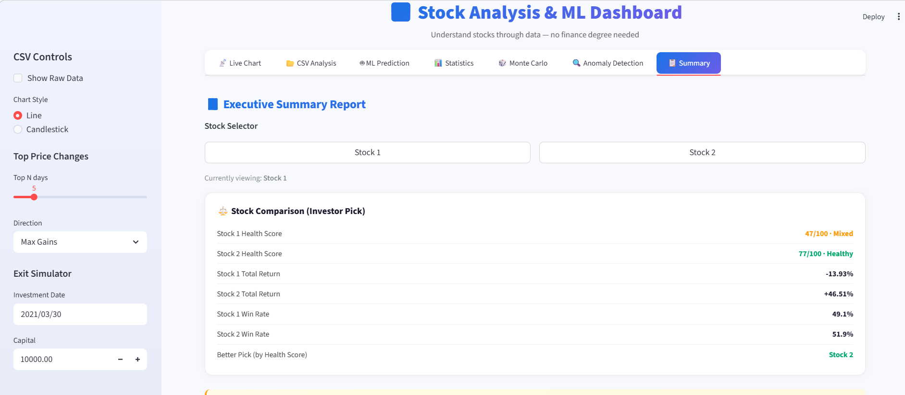

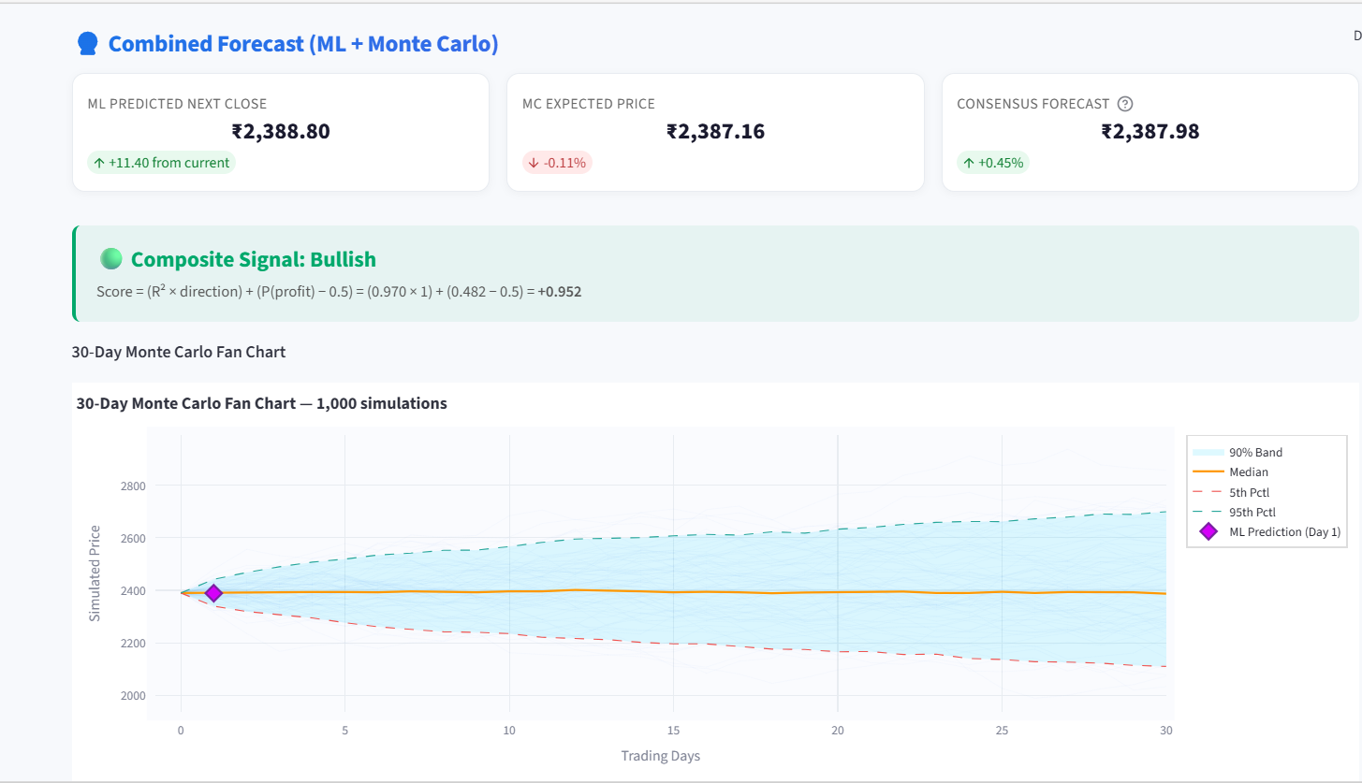

Stock Score – Summary Tab:
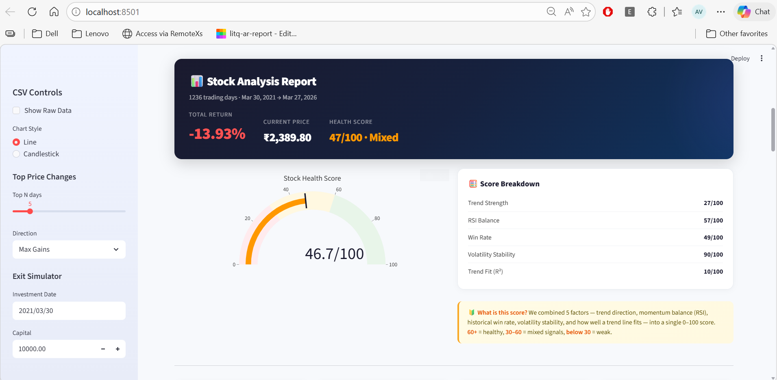

GitHub Repository Link: https://github.com/AdvayV/P-S-Project

